

**DATABASE MANAGEMENT SYSTEM TASK 2**

**GROUP ASSIGNMENT**

**Course code:** (112023-LCP)

**Intake code:** UCDF2307ICT(SE)

**Lecturer: Ms. Lai Chew Peng**

|  |  |
| --- | --- |
| **Group Members** | **Student TP no.** |
| Denesh A/L Sellasamy | TP076723 |
| Chan Zyanne | TP075156 |
| Ang Jianming | TP076671 |
| Shim Yong Lin | TP076209 |

Table of Contents

1.0 Database Schema 3

1.1 Entity Relationship Diagram (ERD) 3

1.2 Database Diagram form DBMS 4

2.0 SQL-Data Definition Language (DDL) 5

2.1 Statement of all Tables 5

2.2 Statement of all Populated Tables 6

3.0 SQL-Data Manipulation Language (DML) 7

3.1 SQL Statement Questions and Answers 7

​​

​

​

​

​

​

​

​​

# 1.0 Database Schema

## 1.1 Entity Relationship Diagram (ERD)

## 1.2 Database Diagram form DBMS

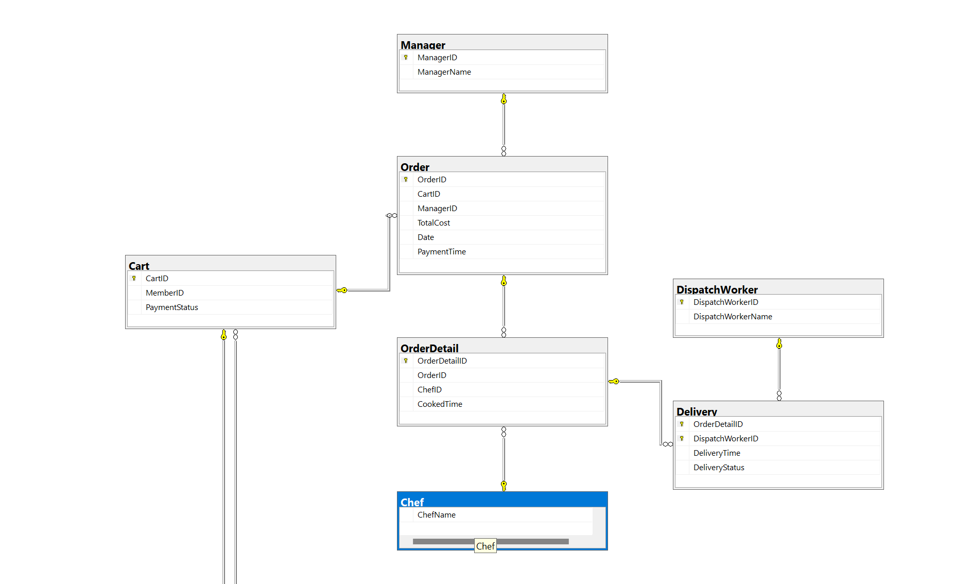

# 2.0 SQL-Data Definition Language (DDL)

## 2.1 Statement of all Tables

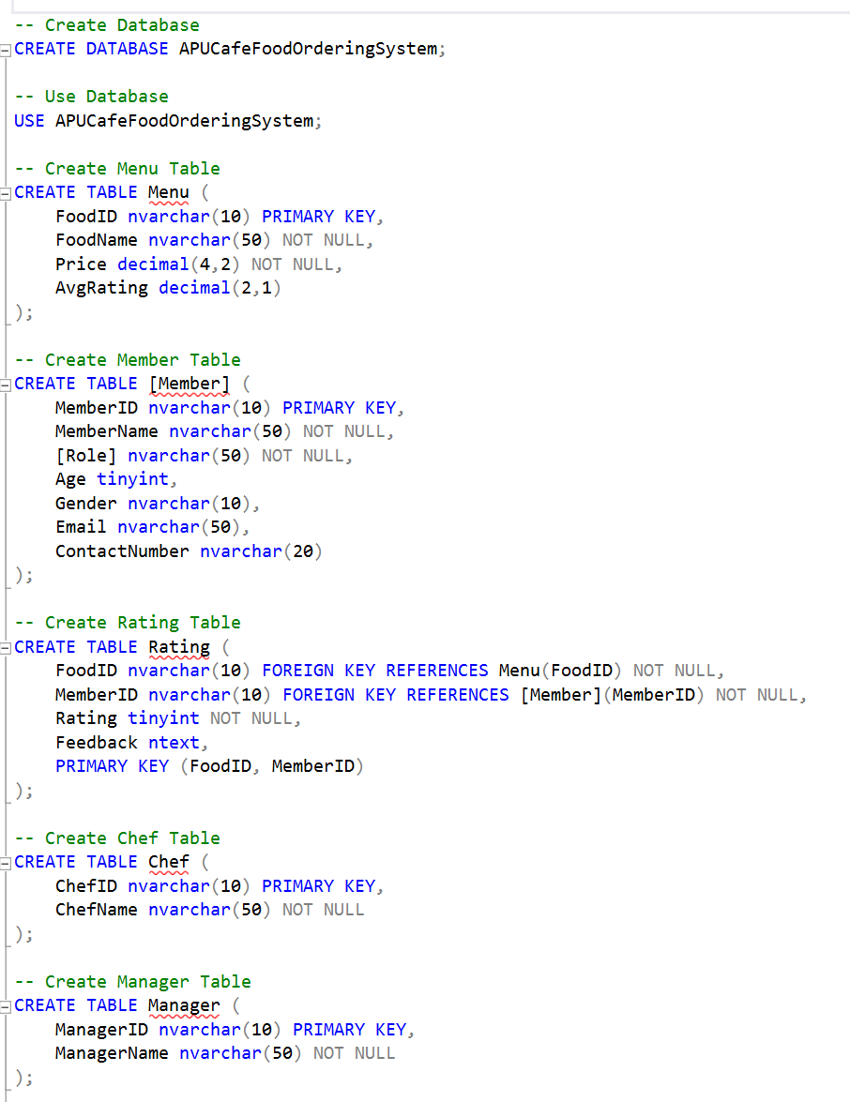

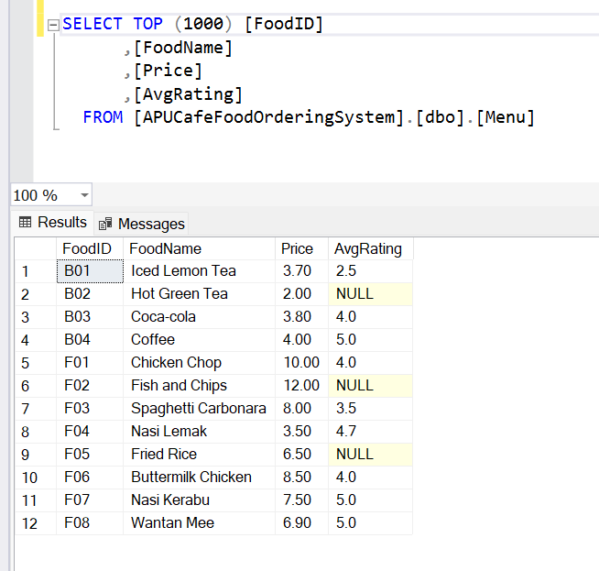

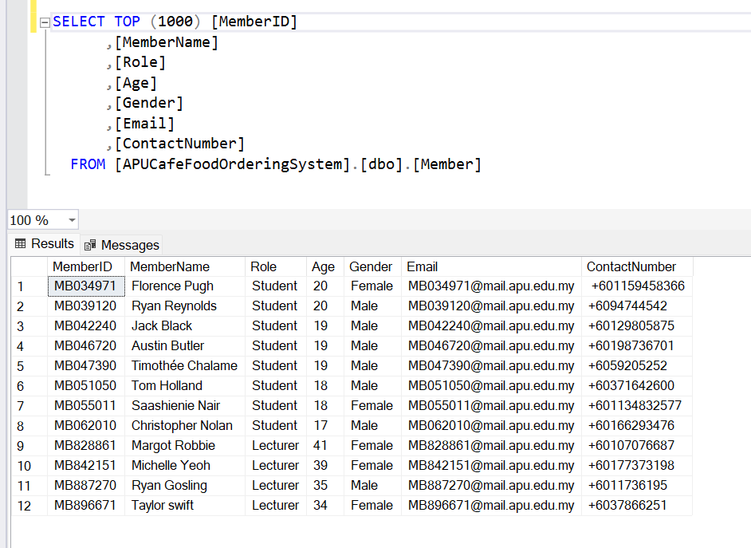

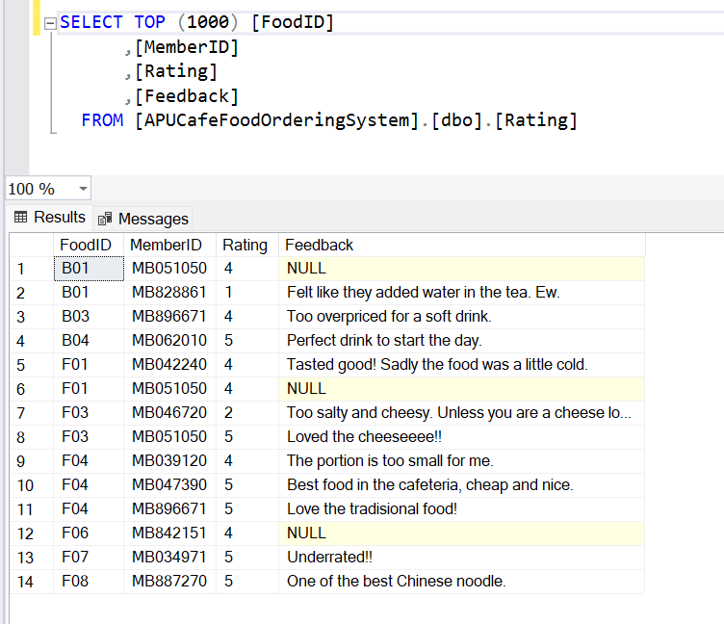

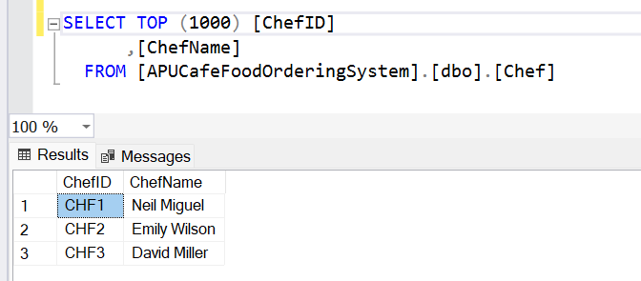

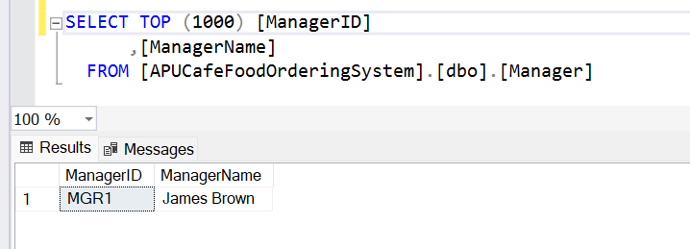

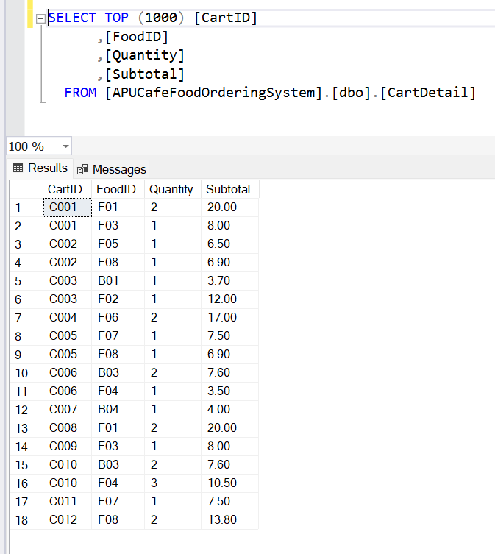

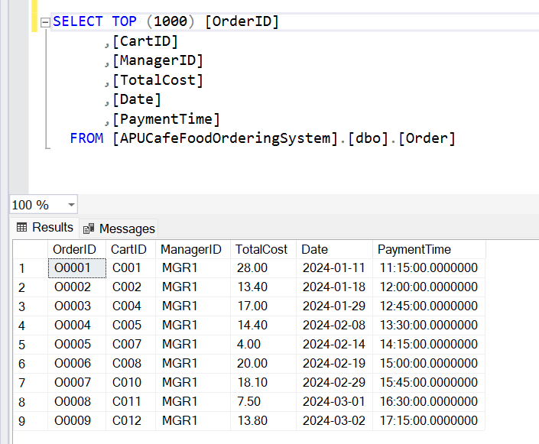

## 2.2 Statement of all Populated Tables

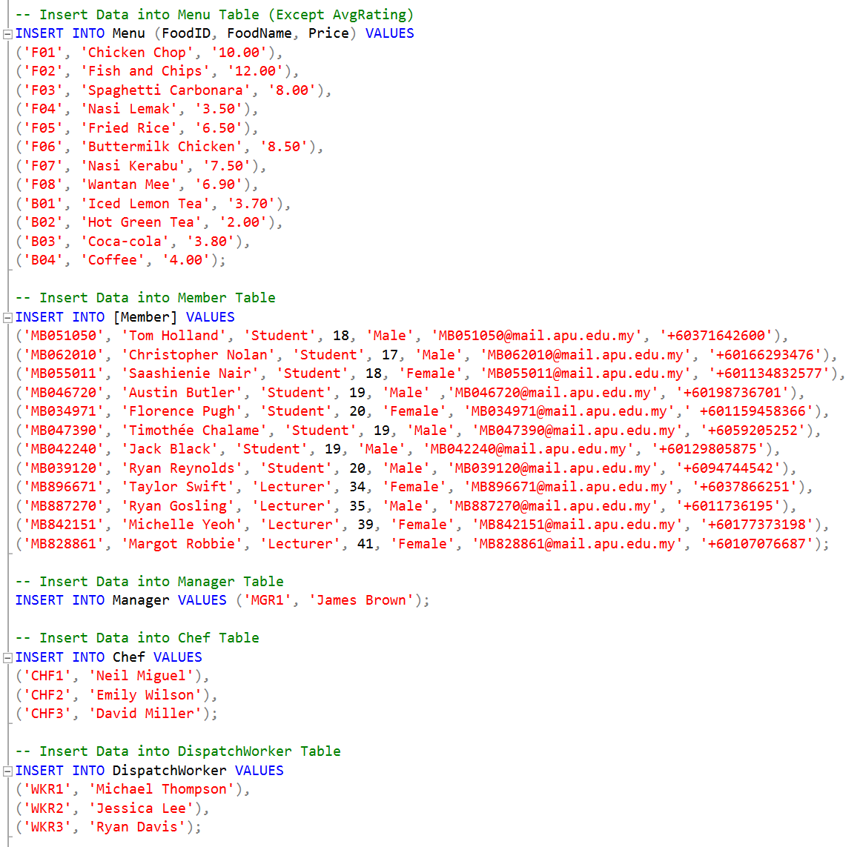

# 3.0 SQL-Data Manipulation Language (DML)

## 3.1 SQL Statement Questions and Answers

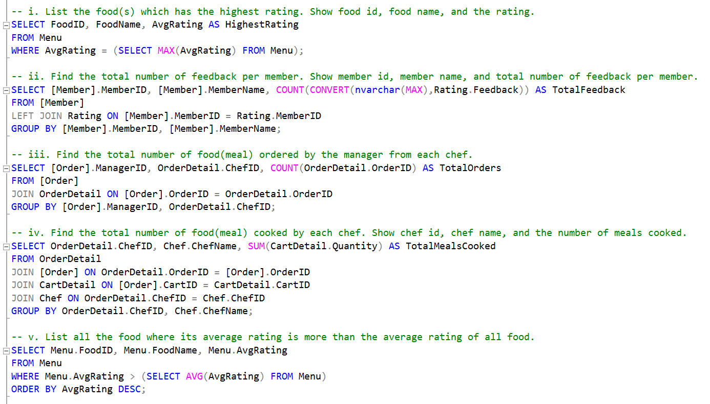

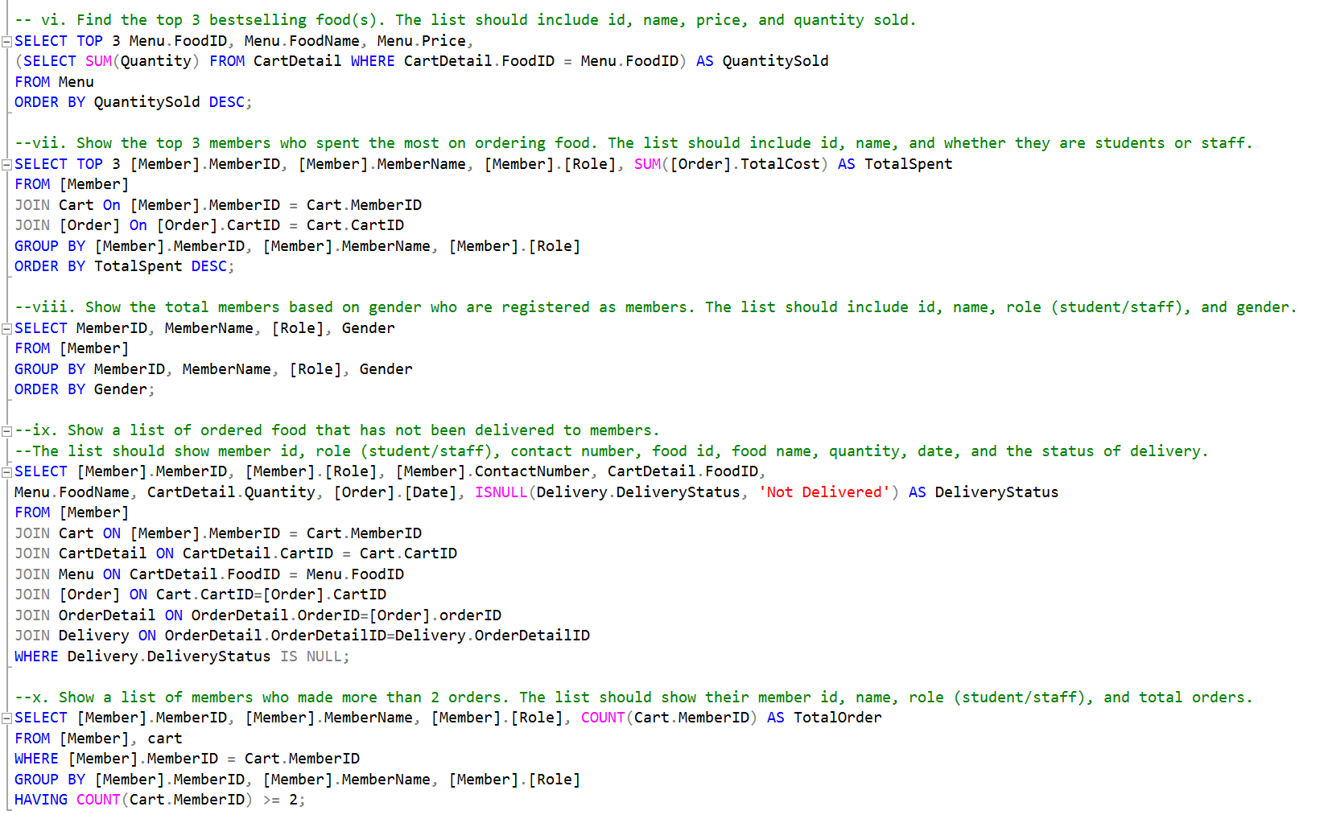

1. A screenshot of a computer

   Description automatically generated
2. A screenshot of a computer

   Description automatically generated
3. 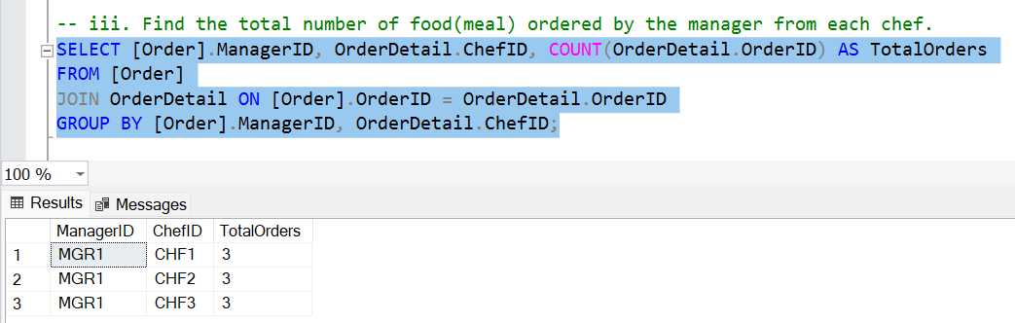
4. A screenshot of a computer

   Description automatically generated
5. 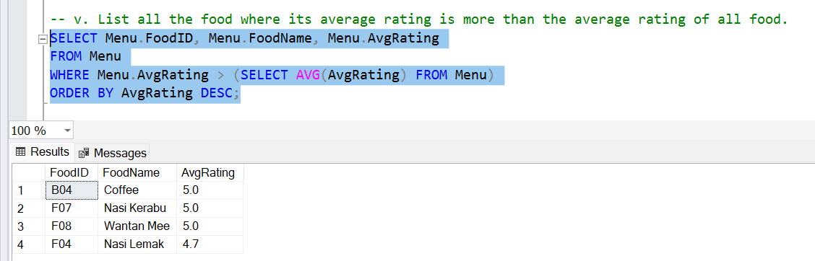
6. A screen shot of a computer

   Description automatically generated
7. A screenshot of a computer

   Description automatically generated
8. A screenshot of a computer

   Description automatically generated
9. Ix